**Cloudant-DB**

**Launch Cloudant DB**

|  |  |
| --- | --- |
| Date | 19 September 2022 |
| Team ID | PNT2022TMID27630 |
| Project Name | VirtualEye - Life Guard for Swimming Pools to Detect Active Drowning |
| Maximum Marks | 4 Marks |

# Step 1: Opening your service instance on IBM Cloudant dashboard

Open your IBM Cloudant service instance by following these steps.

1. Go to the IBM Cloud dashboard.
2. Click **Services** in the Resource list.

|  |
| --- |
| Cloudant-o7 |

1. From the Services section, click the instance that you created in the *Getting started* tutorial, and click **Launch Dashboard**. The IBM Cloudant dashboard opens.

Now, you can create a database, and run queries against it.

# Step 2: Creating a database

|  |
| --- |
| dashboard-demo |

In this exercise, you create the  [database,](https://cloud.ibm.com/apidocs/cloudant#putdatabase) which is the database that you use in this tutorial.

1. From the IBM Cloudant dashboard, click **Create database**.

The Create database window opens.

|  |
| --- |
| dashboard-demo |

1. Enter the database name .
2. Select **Non-partitioned**, and click **Create**.

|  |
| --- |
| dashboard-demo |

The database opens automatically.

Now, you can create some documents.

# Step 3: Adding documents to the database

|  |
| --- |
| dashboard-demo |

that you create in this exercise include the data that you use to query the database in later exercises.

1. Click **Create document**.

The New Document window opens.

1. Copy the following sample text and replace the existing text in the new document. Use the following sample text for document 1:
2. {
3. "firstname": "Sally",
4. "lastname": "Brown",
5. "age": 16,
6. "location": "New York City, NY",
7. "_id": "doc1"
8. }
9. Repeat steps 1 and 2 to add the remaining four documents to the database. Use the following sample text for document 2:
10. {
11. "firstname": "John",
12. "lastname": "Brown",
13. "age": 21,
14. "location": "New York City, NY",
15. "_id": "doc2"
16. }

Use the following sample text for document 3:

{

"firstname": "Greg",

"lastname": "Greene",

"age": 35,

"location": "San Diego, CA",

"_id": "doc3"

}

Use the following sample text for document 4:

{

"firstname": "Anna",

"lastname": "Greene",

"age": 44,

"location": "Baton Rouge, LA",

"_id": "doc4"

}

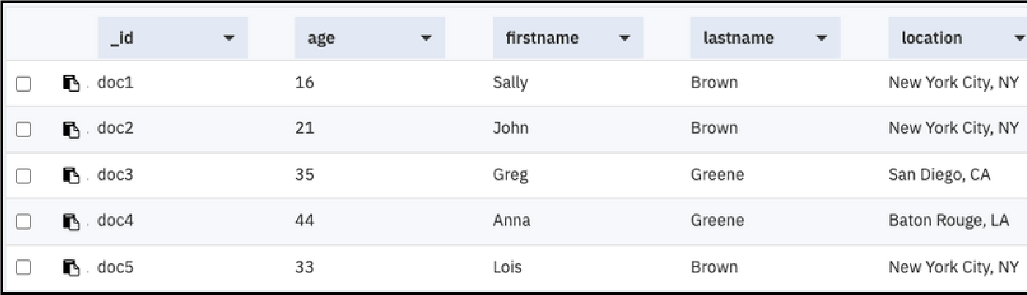Use the following sample text for document 5:

{

"firstname": "Lois",

"lastname": "Brown",

"age": 33,

"location": "New York City, NY",

"_id": "doc5"

}

|  |
| --- |
| dashboard-demo |

You populated the with five documents. You can see the documents from the

Table view in the following screen capture:

## Running a simple query

|  |
| --- |
| lastname |

|  |
| --- |
| firstname |

This example demonstrates how IBM Cloudant Query finds documents based on the and the .

1. Click **Query**.
2. Copy the following sample JSON and replace the existing text in the new query window:
3. {
4. "selector": {
5. "lastname" : "Greene",
6. "firstname" : "Anna"
7. }
8. }
9. Click **Run Query**.

The query displays the results. You can see them from the Table view in the following screen capture:



For more information, see the [IBM Cloudant Query](https://cloud.ibm.com/docs/Cloudant?topic=Cloudant-creating-an-ibm-cloudant-query) tutorial or the API reference on [IBM Cloudant Query.](https://cloud.ibm.com/apidocs/cloudant#getindexesinformation)

# Step 4: Replicating a database

When you replicate a database, it synchronizes the state of two databases: source and target. A replication copies all the changes that happened in the source database to the target database. When a document is deleted from the source database, the document is also deleted from the target database.

For more information, see [Replication.](https://cloud.ibm.com/docs/Cloudant?topic=Cloudant-replication-api#replication-operation)

1. Click **Replication**.
2. Click **New Replication**.

The Job configuration page opens.

Additionally, you can create a replication from the databases page by clicking **Replicate** in the Actions column.

1. Enter the following information for your replication job.

# Step 5: Monitoring active tasks

The Active tasks page displays a list of all running tasks. When you monitor your system's performance, this list can help you find potential issues. You can see a list of active tasks, which includes compaction, replication, and indexing. For more information, see the [Managing tasks](https://cloud.ibm.com/docs/Cloudant?topic=Cloudant-managing-tasks) guide.

If your instance does not have any active tasks, you can return to the previous step, delete the querymovies database, and then replicate it again. If you open the Active Tasks page immediately, you can see

your replication.

1. Click **Active Tasks**.

The Active Tasks page opens.

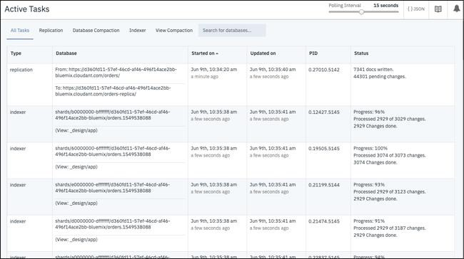

1. Click the associated tab to see task-specific information.

# Step 6: Monitoring with IBM Cloudant

Monitor your usage with a graph that shows your throughput by reads, writes, and global queries. You can see your current operations, denied requests, and storage usage.

Your service instance contains no data because it is for demonstration purposes only. However, you can see what monitoring information is available to you by following these steps.

1. Click **Monitoring**.

The Monitoring page opens to the Current Operations tab. Review recent consumption of provisioned throughput capacity by looking at requests broken down by reads, writes, and global queries. The dotted line is the peak capacity that is allowed for your instance. Peak capacity is based on what is set for your provisioned throughput capacity.

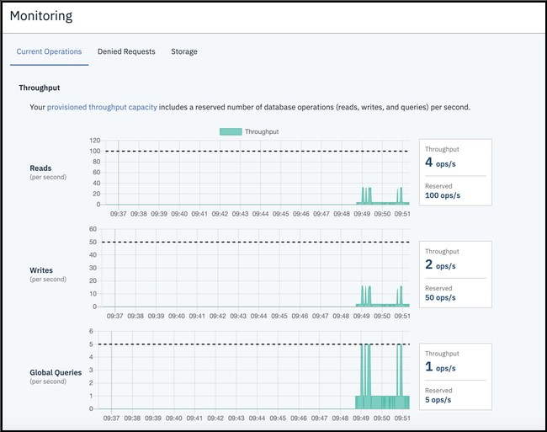

1. Click **Denied Requests**.

|  |
| --- |
| 429: |

|  |
| --- |
| too many requests. |

Review the number of denied requests from a given second that are shown by the number of responses. Requests are denied when they exceed the provisioned

throughput capacity set for the instance. The graph shows the denied requests that are broken down by reads, writes, and global queries.

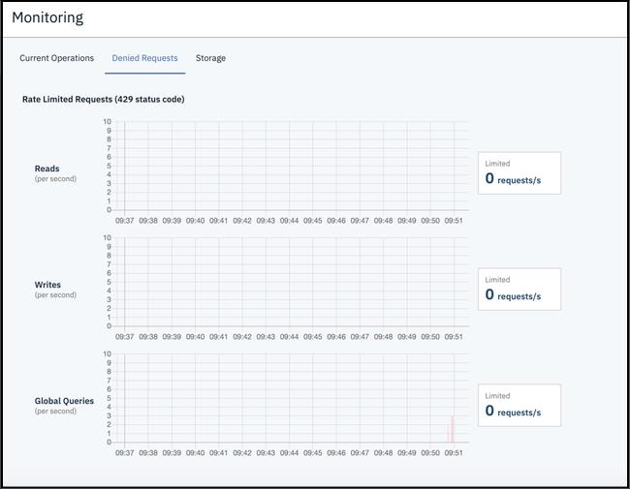

1. Click **Storage**.

Periodically review your storage, so you are prepared if your plan's provisioning needs to be changed.

